Exercise 2

Q1.

Q2.

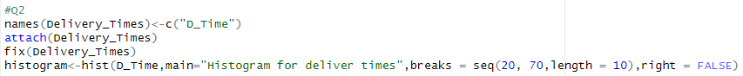

Q3.

Most of the data is at the low end, forming a peak on the left, and a few high values stretch the graph out to the right.

Q4.

